**Q: 6**

**Investors Grid**

**Time to solve the problem**

**20 minutes**

**Level 0**

**Topics**

**Grid**

**Problem Statement**

**Build the following page using grid 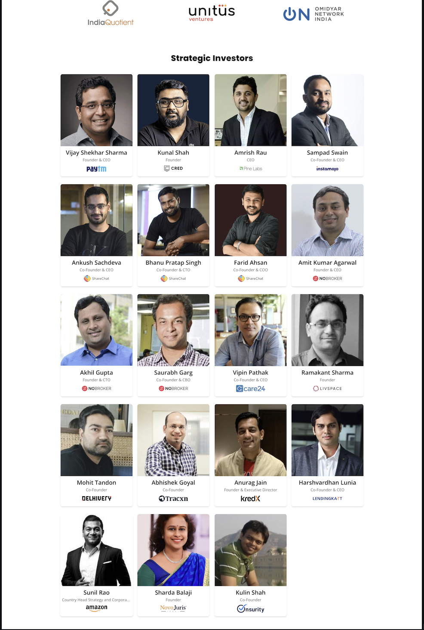 For images refer to**[**https://www.masaischool.com/our-investors/**](https://www.masaischool.com/our-investors/)